Application Form
Orleans House Gallery Winter Show 2026-27
___________________________________________________________________________

To apply, send a completed application form to artsinfo@richmondandwandsworth.gov.uk with the subject line #WS and your name (e.g. #WS Joe Bloggs). Email your completed application document as a Word Document or PDF and attach your artwork image to the same email. Alternatively, you can make arrangement to fill the form out at the gallery if you prefer.

Applications must be received by Wednesday 23 September at 11.59pm. Only artists living, working or studying in the London Borough of Richmond upon Thames are eligible to apply.

Application Timeline:
Applications Close | Wednesday 23 September 2026, 11:59pm
Applicants Notified | Mid-October 2026
Artwork Drop-off | 26 - 30 November 2026
Exhibition Dates | 4 December 2026 - 7 February 2027
Artwork Collection | 8 February 2027

___________________________________________________________________________

1. Name & pronouns:

2. Email address:

3. Your website or social media:

4. Full address including full postcode of where you live, work or study in the borough:

5. Have you worked or exhibited with Richmond Arts Service/Orleans House Gallery before?

6. Where did you hear about this opportunity?

7. Please complete our anonymous Equal Opportunities Monitoring Form

___________________________________________________________________________

The information provided below will be used for interpretation and marketing if the artwork is selected for the exhibition.

1. Artwork title:

2. Medium (materials used):

3. Date (year the artwork was produced):

4a. Dimensions HxW or HxWxD in cm (if framed this must be total size framed):

4b. Weight (if applicable):
5. Image / clip: Please attach 1 high-res image of your artwork to the email with your application. Do not paste the image into this document. If your artwork is a video or sound piece, attach a clip to the email with your application or provide a link to YouTube, Vimeo or SoundCloud.

6. Artist’s statement about the artwork: Please write this in the first person (using I/me pronouns, in your own voice), maximum 50 words, not including artwork title or medium. This will be displayed next to your work during the exhibition:

7. Sale price: Orleans House Gallery receives a commission on all sales of original art and must also charge VAT on our commission rate. The commission is calculated by adding 40% on top of what the artist receives rather than as a percentage of the full sale. If you would like to sell your artwork in this exhibition, please provide:

Artists share:
Orleans House Gallery commission (40% of the above):
VAT (20% ONLY on the commission):
-----
Total selling price:
Pricing example

£100 = Artist’s share
£40 = Orleans House Gallery’s 40% commission
£8 = VAT only on £40 (Orleans House Gallery’s commission)
£148 = total selling price

If you are VAT registered, kindly let us know as we will need to charge VAT on the entire selling price.

The Opportunity
Orleans House Gallery is inviting artists who live, work or study in the London Borough of Richmond upon Thames to submit work for a curated group exhibition at the Stables Gallery.
The exhibition will run from 4 December 2026 to 7 February 2027 and will celebrate the breadth of artistic practice across the borough, showcasing both established and emerging artists. The exhibition aims to celebrate the richness of artistic practice across the borough while providing artists with an opportunity to exhibit, sell their work and connect with new audiences.
We welcome submissions across all visual and contemporary art forms, including both 2D and 3D work. You may submit an existing artwork or propose a new piece created in response to this open call.
We are looking for work that reflects the diversity, creativity and ambition of artists in Richmond upon Thames. As we curate the exhibition, we'll be considering:
- Local Perspectives - Work that reflects local places, people, experiences or ideas, or offers a unique perspective on the world around us.
- Creative Exploration - Work that demonstrates curiosity, experimentation or thoughtful use of materials, processes and ideas.
- Exhibition Potential - Original artworks that will contribute to a varied modular exhibition setting.

As the exhibition takes place during the busy winter season, we're also looking for work that has the potential to connect with visitors and collectors.
We welcome applications from artists at all stages of their careers and particularly encourage submissions from individuals and communities that are currently underrepresented in gallery spaces.
We hope this exhibition provides an accessible opportunity for artists to share their work with new audiences. There is no fee to submit your work.
Orleans House Gallery will:
- Provide the exhibition space and organise an opening event
- Curate and professionally install the exhibition
- Publicise and promote the exhibition
- Process artwork sales
- Invigilate the exhibition throughout opening hours
The deadline for applications is 11.59pm on Wednesday 23 September 2026.
Applicants may submit one artwork for consideration by the selection panel, comprising the Orleans House Gallery team and invited local artist(s).
Each artist may submit one artwork only, even if they work under multiple names or both individually and as part of a collective.
We anticipate a high volume of applications, and unfortunately not all submissions will be selected for exhibition.
If your application is successful, the artwork you submitted as part of your application should be the artwork exhibited. Please therefore submit the work you would like us to consider for the exhibition. We are unable to accept alternative artworks after the selection process has taken place.

Frequently Asked Questions (FAQs)

Can I apply for this artist opportunity at the same time as another opportunity you have live?
Yes!

Can I apply if I live outside the borough?
No, this opportunity is designed for artists who live, work or study within the Borough of Richmond upon Thames.

What file-format should media be sent in?
Please email your completed application document as a Word document or PDF. Please send your image in the same email as an attachment, either as a PDF document, PNG image or JPEG/JPG image. Kindly note that we are unable to access applications sent as Pages documents, WeTransfer file transfers, Dropbox folders/links or Google Drive links.

Here’s a list of additional file-formats we are able to receive: Windows Media formats (.asf, .wma, .wmv, .wm) Audio Visual Interleave (.avi) Moving Pictures Experts Group (.mpg, .mpeg, .m1v, .mp2, .mp3, .mpa, .mpe, .m3u) Musical Instrument Digital Interface (.mid, .midi, .rmi) Audio Interchange File Format (.aif, .aifc, .aiff) Audio for Windows (.wav) QuickTime Movie file (.mov) MP4 Audio file (.m4a) MP4 Video file (.mp4, .m4v, .mp4v, .3g2, .3gp2, .3gp, .3gpp)

When do I find out if any of my work has been chosen?
Applicants will be notified either way by email in mid-October 2026. Due to the volume of application we receive, we are unable to provide feedback on applications.

If my work is chosen, will I be able to also sell a print run or postcards in the gallery shop?
Unfortunately, you will only be able to sell the artwork itself, as there isn’t capacity to be able to process additional sales.

Can I submit numerous works as one piece (i.e diptych/triptych)?
Yes, however numerous works exhibited as one piece must be sold as such. Artists are not permitted to submit multiple pieces that are intended to be sold or exhibited separately.

Can I submit work requiring a power supply?
Yes, however any items requiring mains power will need to be PAT tested privately (if selected), and a certificate of completion delivered to the gallery when artwork is dropped off.

Can I sell work with the option to sell framed or unframed?
Works that are presented in a frame must be sold as such. Artworks that are intended to be hung on the wall must include a frame or an appropriate hanging mechanism, provided by the artist (ex: A stretched canvas might not need a frame). Orleans House Gallery is not able to provide frames for artworks.

Is there a size limit?
No. However, as this is a group exhibition, offering a chance for many individuals to contribute is important to us. The dimensions of the Stables Gallery are shown below to show the physical limitations of the space. Please consider door width for large artworks.

Will my work be insured by Orleans House Gallery?
The Stables Gallery is invigilated throughout opening hours, but artwork is displayed at the artist’s own risk. Orleans House Gallery will insure work at a market value if there are at least two examples of evidence which support the valuation. This might be an earlier sale of a similar piece or valuation by a recognised third party. The valuation may be different from the sale price. Artwork is insured only once it is installed and the exhibition is signed off by the Operations team. The artwork is not insured by Orleans House Gallery when it is in transit or offsite.

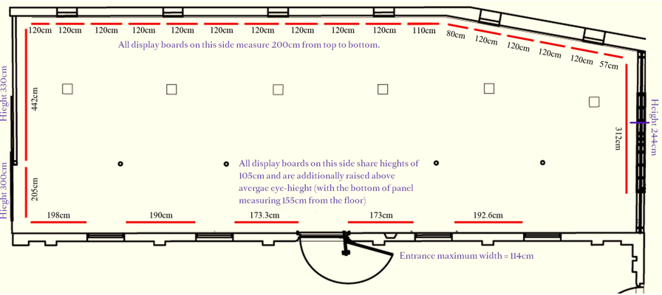

Does 2D work need to come ready to hang e.g. with fixings attached?
Yes, adequate fixings must be attached to your work. There are many acceptable hanging systems suitable for supporting works of art for long periods of time. Some examples of these are listed below. Orleans House Gallery may switch the fixings. If this is necessary, it will be completed by a trained technician, and you may not receive the original fixings back.

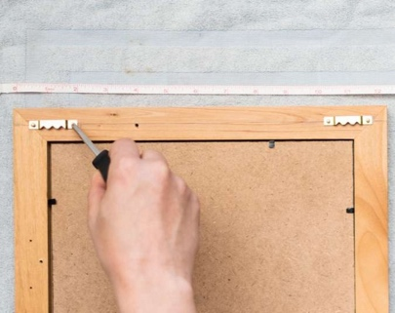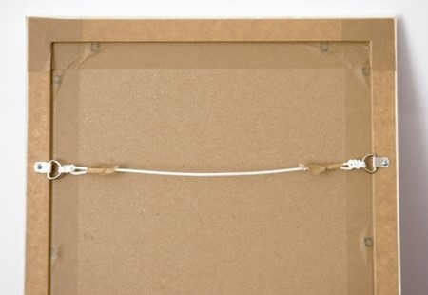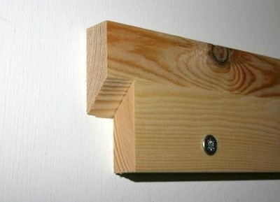
Sawtooth hanging brackets String/wire (D-rings) Split batten

What about 3D work?
3D work must arrive stable, ready to be placed on a surface or with its own secure display method.

What about audio-visual work?
The artist must provide any media players, suitable monitors, screens, projectors, headphones, etc. and simple instructions for turning the artwork on and off.

I have seen the Christmas Shopping Weekend advertised, is this the same as the Winter Show?
These are two separate opportunities, and you are welcome to apply for both. Please note that on Saturday 5 December & Sunday 6 December the annual Christmas Shopping Weekend at Orleans House Gallery will take place, with over 50 independent makers, sellers and artisans animating the site, including the Stables Gallery. There will be up to 12 artist pitches in the Stables Gallery across the weekend and your application to participate in the Winter Show does not include a pitch at this event. If you are interested in applying to take part in the Christmas Shopping Weekend at Orleans House Gallery, you can find more information on our website.

Will there be an opening celebration?
Yes! The Winter Show will launch with a special event on the evening of Friday 4 December. Visitors will be offered an exclusive first look at the works on display. There will be refreshments (available for purchase) and entertainment in the Stables Café which adjoins the gallery. The event will serve as the launch of our exciting winter season at Orleans House Gallery.

How do I contact someone if I have additional questions?
If you have any other questions or queries, please email Arts Info artsinfo@richmondandwandsworth.gov.uk or call 020 8831 6000.

